**Window in JavaScript:**

Window object represents the browser window or tab containing DOM document. It acts as global object, providing methods and properties related to the browser environment, including navigation, location, history, and timing.

**Key Characteristics**

* **Global Scope:**

Window object serves as the global scope in JavaScript, meaning variables and functions declared without the var, let, or const keyword become properties of the window object.

* **Browser Information:**

window object offers properties like window.innerWidth, window.innerHeight, and window. navigator to provide information about the browser's dimensions, navigator object, and other related details.

* **Navigation:**

Methods such as window.open(), window.close(), and window.location allow developers to control browser navigation, open new windows or tabs, and manipulate the current URL.

* **Timers:**

The window object provides functions like setTimeout(), setInterval(), and clearTimeout() to manage time-based operations and execute code asynchronously.

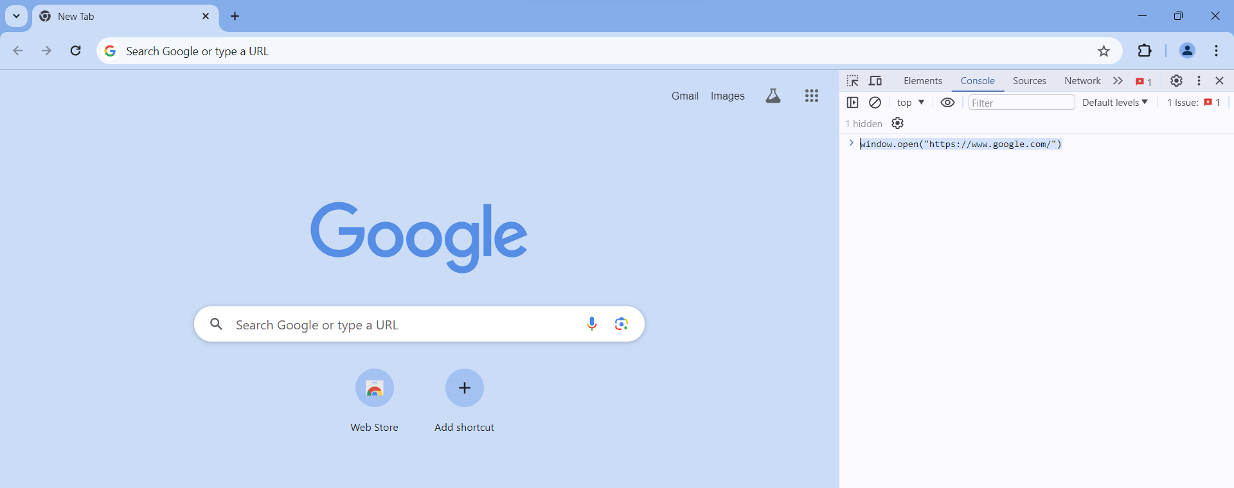

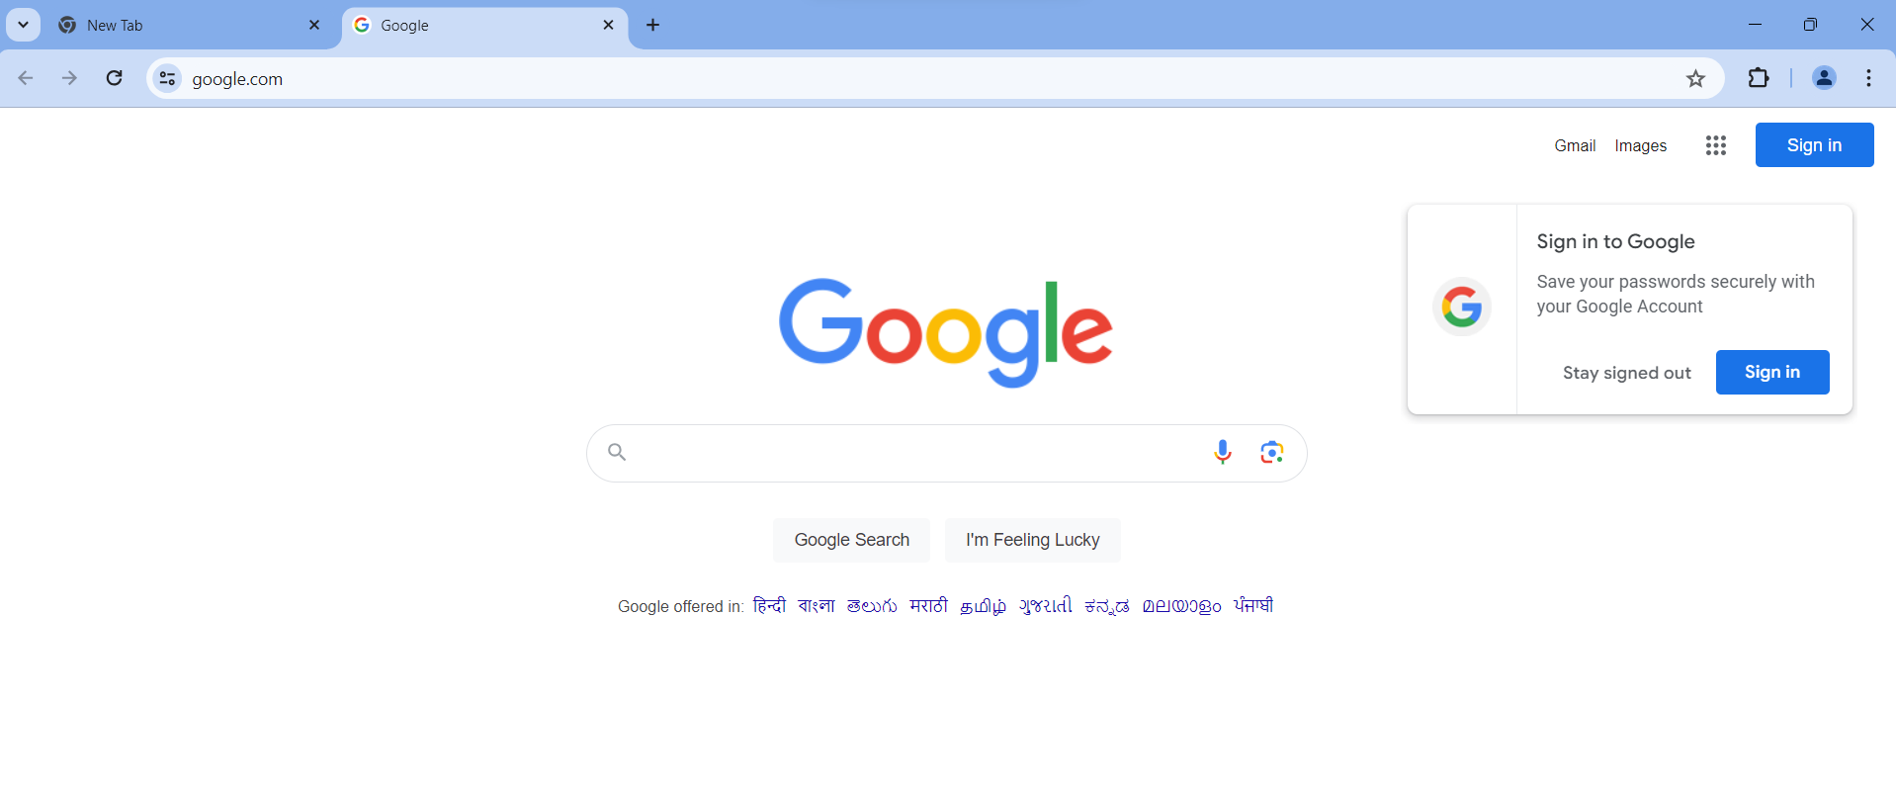

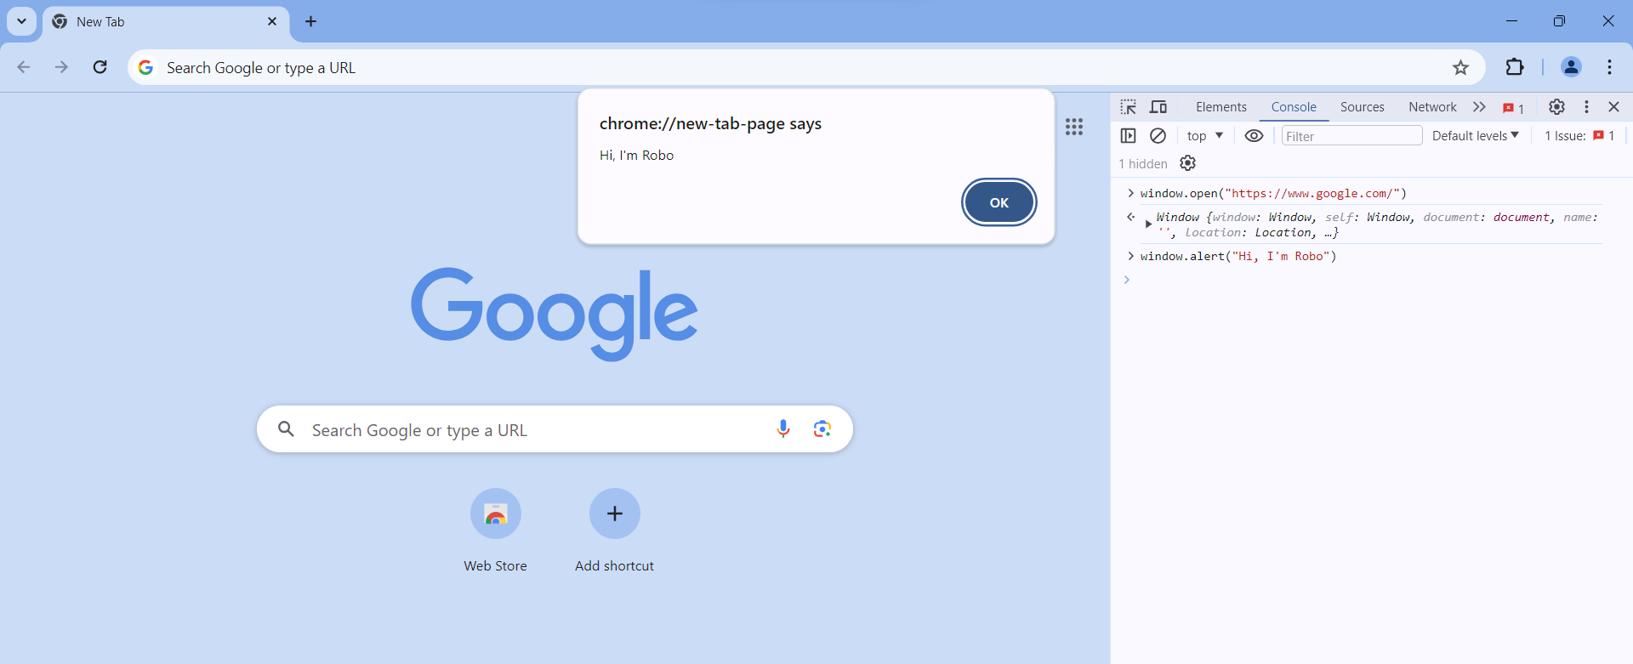

**Document Object in JavaScript:**

The document object represents the entire HTML document within a browser window. It serves as an interface to access and manipulate the content, structure, and styles of a web page.

**Key Characteristics:**

* **DOM Structure:**

The document object provides a hierarchical representation of the HTML elements on a webpage, allowing developers to navigate, modify, and manipulate the content dynamically.

* **Methods:**

The document object offers methods like getElementById(), getElementsByClassName(), and querySelector(), enabling developers to select specific elements based on their IDs, classes, or other attributes.

* **Properties:**

Properties such as document.title, document.URL, and document.body provide information about the document's title, URL, and body, respectively.

* **Content Manipulation:**

Through the document object, you can dynamically create, modify, or delete elements, attributes, and text content on a webpage.

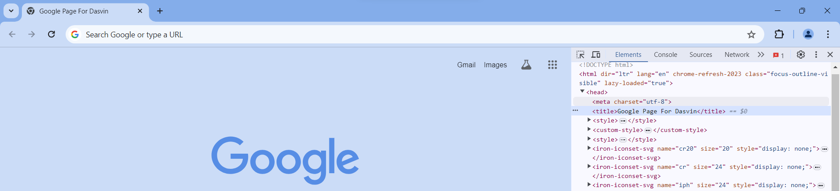

**Window VS Document Objects in JS**

|  |  |
| --- | --- |
| **Window** | **Document** |
| It represents a browser window or frame that displays the contents of the webpage. | It represents any HTML document or web page that is loaded in the browser. |
| It is the very first object that is loaded in the browser. | It is loaded inside the window. |
| It is the object of the browser. | It is the object of window property. |
| Global objects, functions, and variables of JavaScript are members of the window object. | All the tags, elements with attributes in HTML are part of the document. |
| We can access the window from the window only. i.e. window.window | We can access the document from a window using the window. Document |
| The window is part of BOM, not DOM. | The document is part of BOM (browser object model) and dom (Document object model). |
| Properties of the window object cannot be accessed by the document object. | Properties of document objects such as title, body, cookies, etc can also be accessed by a window like this window.document.title. |